
EAS-IPM
Design Document – P2P Process Network
1.0


 | Prepared By / Last Updated By | Reviewed By | Approved By
Name | Nisha.M.R |  | Vinod Kumar Pai
Role | Developer |  | Associate Director, Projects
Signature
Date

Table of Contents

Introduction 4
1.1 Purpose 4
1.2 Intended Audience 4
1.3 Background 4
1.4 Supporting Documentation 4
1.5 Requirement Scope 4
1.5.1 Impact Analysis 4
1.6 Assumptions and Dependencies 4
1.7 Definitions and Acronyms 4
1.8 Document Conventions 4
1.9 Access Methods and Protocols 4
1.10 Business Context Diagram 4
1.11 High Level Architectural Diagram 4
1.12 Flow Diagram 4
1.13 Orchestration Summary Table 5
1.13.1 Request-Reply from <> to <> 5
1.14 Common Data Model 5
1.15 <Service Name> 6
1.15.1 Purpose 6
1.15.2 Pre-conditions 6
1.15.3 Type 6
1.16 Mapping Specifications 6
1.17 Cast Iron Orchestration Flow 6
1.17.1 Orchestrations 6
1.17.2 Orchestration Diagram 6
1.17.3 Orchestration Logic 7
1.17.4 Application Endpoints 7
1.17.5 Schema information (XSD/WSDLS) 7
1.17.6 Orchestration Activities 7
1.17.7 Orchestration Error Handling Logic 7
1.17.8 Other Orchestration settings/Project preferences (if any) 7
1.17.9 Project Configuration Details 7
1.17.1 Global Configuration Details (if any) 7
1.18 Database Design Details 7
1.19 WMC Server Details 8
1.20 Solution Specification to Non-Functional Requirements 8
1.21 Error Logging & Exception Handling 8
1.21.1 Error Logging 8
1.21.2 Exception Handling 8
1.21.3 Design Constraints 8
1.22 Issues 8
1.23 Attachments 8
1.24 References 8
1.25 Change Log 9

Introduction

Purpose
The purpose of this document us to provide an explanation of the Procure to Pay Network

Intended Audience
This document is targeted only for developers who plan to create smart contracts for blockchain solutions using chaincode

Background
procure-to-pay(PTP) is the multi-step process blockchain solution that connects a client with one or more service/product providers. It also allows for the identification and authentication of stake holders, service provisioning, budgeting, invoicing, and payment settlement. The network tracks the flow of purchase order created by manufacturer till the consumption is done and the payment is received by supplier of the purchase order.

Requirements and Dependencies
The following are used to build the application.
- Hyperledger Fabric – 1.4
- Node JS - v8.11.3
- GoLang - go1.12 darwin-amd64
- Angular JS
- IDE – Visual Studio Code

Network Architecture
The application is divided into 3 layers.
- User Interaction Layer
- SDK Layer
- Blockchain Layer

User Interaction layer
The user interaction layer includes a presentation layer. This layer is built using Angular JS and CSS.

SDK Layer
This is the middle/interface layer which is the gateway to the blockchain. The middle layer provides the communication between user interaction layer and the blockchain layer. This layer is built using Node js. Java SDK is also available. The transaction submitted by the user is routed to controller file which is the node layer via a routes.js file. The controller file will have the orderer address and peer address which are participating in the network. The named of installed chaincode, the transaction and the arguments of the transaction is send to the chaincode in the form of request. The transaction is sent using sendTransactionProposal. The proposal response will be sent back to sdk by the chaincode and this response can be sent back to UI. For query transaction, the request is sent to chaincode using querybyChaincode.
Controller.js syntax
module.exports = (function() {
return{
PlaceOrder: function(req, res){
var channel = fabric_client.newChannel('mychannel');
var peer1 = fabric_client.newPeer('grpc://localhost:7051');
var peer2 = fabric_client.newPeer('grpc://localhost:8051');
var peer3 = fabric_client.newPeer('grpc://localhost:9051');
var peer4 = fabric_client.newPeer('grpc://localhost:10051');
channel.addPeer(peer1);
channel.addPeer(peer2);
channel.addPeer(peer3);
channel.addPeer(peer4);
var order = fabric_client.newOrderer('grpc://localhost:7050')
channel.addOrderer(order);

const request = {
//targets : --- letting this default to the peers assigned to the channel
chaincodeId: 'p2pchaincode',
fcn: 'placeOrder',
args: [poNumber, materialCode, lineNumber, orderQuantity, uop, deliveryDat e, creationDate, price, currency, supplier],
txId: tx_id
};
// send the transaction proposal to the peers
return channel.sendTransactionProposal(request);

}
}
});

Blockchain Layer
In the blockchain layer we have the chaincode or smart contract. The chaincode is made using Golang. The call to chaincode is done through SDK. The explanation of chaincode and the functions implemented ae explained in later section.

Application Participants
- Manufacturer
- Supplier

Application Description
There are two organizations in the network – Manufacturer & Supplier. In the network implementation, these two are defined as org1 and org2. The two organizations have two peer each of which one is the endorsement peer. The network is using orderer type of solo. A channel named “mychannel” is created and all the four peers are joined to the channel. There is a script file to start the hyperledger fabric network and to install the chaincode. While running the script file the peer, chaincode, orderer and ca containers are created.
For running our chaincode on the fabric network there are a series of steps to be followed.
- Download the fabric samples from GitHub repository
- In the first-Network folder, we have to run the byfn.sh file to make our network up and running.
- Modify the scripts.sh and utils.sh file inside the scripts folder according to our smart contract.
- In script.sh file specify the path to chaincode.
- In the utils.sh specify the commands to install, instantiate and invoke the chaincode

peer chaincode install -n p2pchaincode -v ${VERSION} -l ${LANGUAGE} -p ${CC_SRC_PATH} >&log.txt

peer chaincode instantiate -o orderer.example.com:7050 -C $CHANNEL_NAME -n p2pchaincode -l ${LANGUAGE} -v ${VERSION} -c '{"Args":["init"]}' -P "OR ('Org1MSP.member','Org2MSP.member')" >&log.txt

peer chaincode invoke -o orderer.example.com:7050 -C mychannel -n p2pchaincode $PEER_CONN_PARMS -c '{"Args":["placeOrder","M1","PO1","L1","100","DOZEN","10-10-2-18","10-09-2018","1000","USD","FLEXTRONICS"]}' >&log.txt

Flow Diagram
MANUFACTURER
Place Order/ Bulk Upload

Place Order/Bulk Upload

SUPPLIER
Shipment Notification

Shipment Notification

MANUFACTUER
Goods Receipt
Send Notification to manufacturer and supplier
If difference between current date and receipt date is > 90
MANUFACTURER
Consumption (Invoice Generated)

Goods ReceipMANt
MANUFACTURER
Self-Invoice Generated

Self-Invoice Generated

SUPPLIER
Invoice Approved

Payment Done

MANUFACTURER
Payment Done

Invoice Approved

Chaincode
The chaincode is written in Golang. The packages needed for implementation are imported from “Shim”. The important functions defined for the chaincode are
- Init
Init function is called during initialization or updte done on the chaincode. Init function takes ChaincodeStubInterface as parameter. When we call this function from CLI, it responds back with the peer response.
func (t *ProcureToPayChaincode) Init(stub shim.ChaincodeStubInterface) pb.Response {}
- Invoke
All the logic implementation functions are written here. These implementation functions are called transactions. There are insert, update and query transactions. The transaction list is explained later.
Syntax:
func (t *ProcureToPayChaincode) Init(stub shim.ChaincodeStubInterface) pb.Response {
function, args := stub.GetFunctionAndParameters()
if function == “placeOrder”{
return t.placeOrder(stub, args)
}
return shim.Error(“Error invoking function”)
}

Assets
The following assets are defined in the chaincode.
- Material
The material for which the purchase order is created. Identified by material code. Purchase order details will be stored in material in the form of array
- Purchase Order
Purchase order contains the details of the order for a particular material. Identified by po number. Batch details will be stored in this asset in form of array.
- Batch
The details of the batch which is shipped, received or invoice generated is stored in this asset. Identified by batch code.
- Invoice
The details of invoice generated by the manufacturer when a consumption is done or the invoice generated due to overdue is stored in invoice. Identified by invDocNum.

Transactions
- PlaceOrder
The manufacturer places an order to supplier or they can submit bulk orders. Purchase Order asset is created and also the purchase order details is stored in material asset.
- shipmentNotification
Supplier supplies the order in batches to manufacturer.
- goodsReceipt
Manufacturer updates the material, batch and purchase order assets when the batch is received
- recordConsumption
Manufacturer consumes the product and the invoice is generated
- generateInvoice
If the difference in number of dates between current date and date of receiving the batch is greater than 90, the notification will be sent to manufacturer and s supplier. Manufacturer then generates the invoice for that batch. This functionality is implemented in this transaction.
- invoiceStatus
This transaction is for changing the status of invoice when invoice is approved by supplier and payment is completed by manufacturer. The invoice generated by manufacturer has to be approved by supplier before sending the invoice for payment. After approving the invoice, it is send for payment.
- Search
This transaction is to search the assets using their identifier.

Running Network
For running the application, we have to start the fabric network, install the chaincode and then the node SDK is started. The following steps have to be followed.
- Navigate to the folder which contain the shell script for starting the fabric. Here there is a startFabric.sh script. When we run this script, it will call the byfn.sh script in the network folder.
./startFabric.sh
If this script is run successfully, the following result will be displayed.

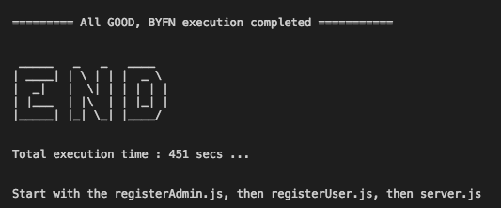

- We can see the list of containers that is up and running.
docker ps -a

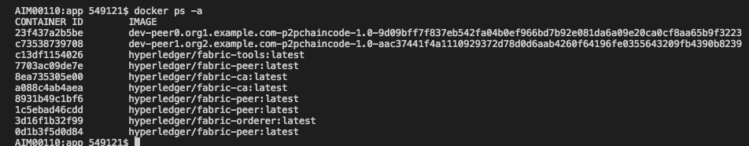
Now the chaincode is installed and instantiated in all the peers of the channel.
- Node modules
The required node modules need to be installed. This is done using command
npm start
This will install the packages that are predefined in package.json. If any error specifying package is not available, we can install that using command npm install.
- registerAdmin.js and registerUser.js
The admin and users have to be enrolled for each ca. In the network since this is multi org, there are two ca containers and using the certificate file of ca we have to enroll admin and user.
For enrolling admin
node registerAdmin.js
For enrolling user
node registerUser.js
This will create a hfc-key-store in the SDK folder and create the user and admin. This is later used by controller when committing a transaction.
- Now we have to start the node app
Go to the root folder and hit the following command
npm start OR node server.js
The following will be displayed if the app is started successfully

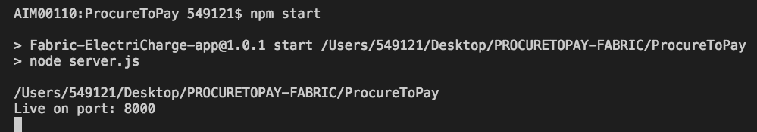

We can hit the application at http://localhost:8000/

